SOLUTION ARCHITECTURE

Nutrition Assistant Application

***Team Members: Mridula k, Mohanapriya, Sneha M.G, Hari Raja M.***

# PROJECT DESCRIPTION:

# Due to the ignorance of healthy food habits, obesity rates are increasing at an alarming speed, and this is reflective of the risks to people’s health. People need to control their daily calorie intake by eating healthier foods, which is the most basic method to avoid obesity. However, although food packaging comes with nutrition (and calorie) labels, it’s still not very convenient for people to refer to App-based nutrient dashboard systems which can analyze real-time images of a meal and analyze it for nutritional content which can be very handy and improves the dietary habits, and therefore, helps in maintaining a healthy lifestyle.This project aims at building a web App that automatically estimates food attributes such as ingredients and nutritional value by classifying the input image of food. Our method employs Clarifai's AI-Driven Food Detection Model for accurate food identification and Food API's to give the nutritional value of the identified food.

# TECHNICAL ARCHITECTURE:

Block Diagram of the model proposed:

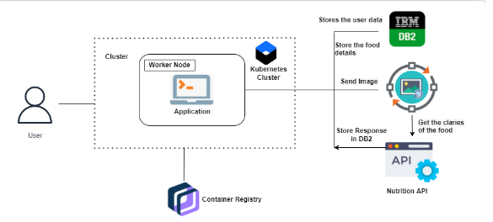

**SOLUTION:**

* User interacts with the Web App to Load an image.
* The image is passed to the server application, which uses Clarifai's AI-Driven Food Detection Model Service to analyze the images and Nutrition API to provide nutritional information about the analyzed Image.
* Nutritional information of the analyzed image is returned to the app for display.

# PROCEDURE:

### 1. Implementing Web Application

* Registration (Push the registration data into the database)
* Login (Fetch the data upon login)
* Upload the food image and get the prediction
* Get Calories from the food items
* Add food data to the database

`2. Create UI to interact with the application

* Registration Page
* Login Page
* Upload Image page
* Prediction results page for food items
* View history of items

### 3. Create IBM DB2 And Connect With Python

* Create the IBM Db2 service in the IBM cloud and connect the python code with DB.

### 4. Integrate Nutrition API

* Integrate the Nutrition API to the flask with API call.

**Approach**:

Nutrition assistant application is designed to compress the broad knowledge that exists in nutrition, Many people will attract to Nutrition because they had special dietary needs. Some had food allergies or sensitivities; others were vegan or vegetarian; many were pregnant. A number of pregnant women reached out to us asking for more detailed information and guidance.

* **Kubernetes clusters** - Kubernetes clusters allow containers to run across multiple machines and cloud based application.
* **IBM DB2**- Used for Backup & recovery. Comprehensive data resilience for physical and virtual servers.Cloud hosting. Dedicated, virtual private, and bare metal server options
* **Container Registry** - Container Registry is a single place for your team to manage Docker images, perform vulnerability analysis, and decide who can access what with fine-grained access control
* **Nutrition API** - A nutrition API acts as a container for information from thousands of products. When an application sends a GET request to the API, it returns the nutrition information about a given product.

# RESULT:

Despite processing, we do not believe that our outcomes are flawless. There is always opportunity for improvement in your procedure because cloud computing is a topic that is constantly developing. Additionally, there will always be new approaches that offer better results for the same problems. It has been done, the application. Clarifai's AI-Driven Food Detection Model Service, Nutrition API.